
JBOG 0.1 Mechanical requirements



Author:
Jean-Jacques Chanut, Mechanical engineer Sesame
Issue date: 04/22/2020

Contents

1. Table of figures 3
2. Revision History 3
3. Scope 3
4. Overview 3
5. NVIDI Quadro and Tesla requirements 4
1) Thermal 4
2) Mechanical dimension 4
3) Power connection 5
4) NVLink placement 5
6. Open Rack V2 mechanical requirement 6
1) Mechanical overview 6
2) Required Sled Features and Dimensions 6
3) Sled Retention 7
4) Weight Rating 7
5) Cubby and Fast Start chassis power connectors 7
6) Cubby reference drawing 7
7) Standard sled design reference drawing 8
7. JBOG mechanical architecture 9
1) Architecture overview 9
2) Mechanical dimensions 10
8. Thermal requirements 10
9. Electrical requirement 10
1) Power distribution 10
2) Electrical grounding 10
10. Standards 10

Table of figures
Figure 1: PCIE interface diagram 4
Figure 2: NVIDIA card mechanical dimension 5
Figure 3 power connectors 5
Figure 4 NVLink connector 6
Figure 5 Cubby Shelf overview 6
Figure 6 Sled design envelope 7
Figure 7 Cubby shelf reference drawing 8
Figure 8 : Standard ORV2 Sled dimensions 9
Figure 9 : Standard Sled ORV2 components zone 10
Figure 10 : Mechanical architecture 11

Revision History

Date | Name | Description
04/22/2019 | JJ Chanut | Creation

Scope

This document provides the technical requirements for the design of the discovery chassis so that it is ORV2 an Sesame fast start compatible, and meets the thermal specifications.

Overview

JBOG is a 2OU chassis open rack V2 sled design compatible integrating 4 full length double slot GPUs (NVIDIA Quadro and Tesla products).
JBOD is masters by a compute node thanks to 4 mini SAS HD cables.
The PCIe boards are plugged on a vertical riser and are arranged two by two and aligned horizontally on the right side of the server.
The JBOG includes 4 mini SAS HD ports, a USB port and an RJ45 port.
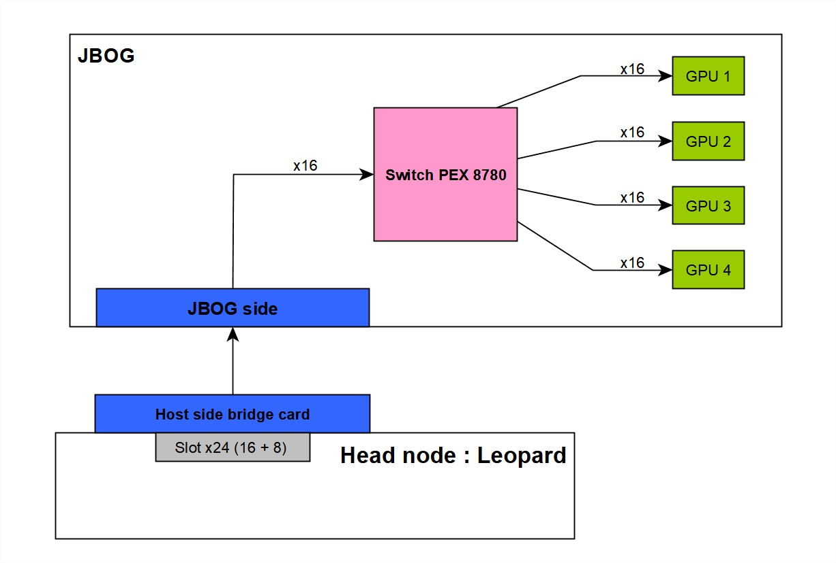
Figure 1: PCIE interface diagram

NVIDI Quadro and Tesla requirements

Thermal
NVIDIA Quadro and TESLA Thermal specification:
Parameter | Value | Units
Max Total graphics power (TGP) | 260 | W
GPU shutdown temperature | 94 | °C
GPU slowdown temperature (50% clock slowdown) | 91 | °C
GPU target temperature | 84 | °C
GPU maximum operating temperature | 89 | °C
Maximum fan inlet temperature | 45 | °C

Mechanical dimension
The Tesla and Quadro PCIe board conform to NVIDIA Form Factor 3.0 and form factor 4.0 specification. Thickness is 40mm.
Figure 2: NVIDIA card mechanical dimension

Power connection
The board provides power connection on the east edge of the board, it can be with one or two connectors:
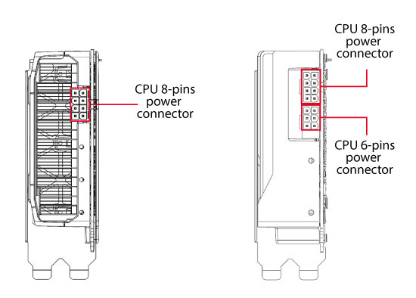
Figure 3 power connectors

NVLink placement
Nvidia cards allow NVLink via SLI connection:
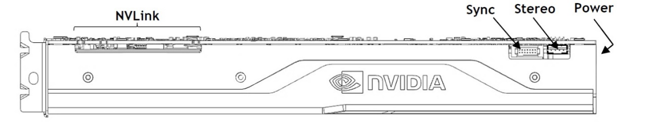
Figure 4 NVLink connector
From ATX standard specification 2.2, the spacing between 2 PCIe slots is 0.8 in, in order to allow an SLI connection between two x2 slots GPUs a gap of 1.6 inches is required.

Open Rack V2 mechanical requirement
This section serves as a guideline for the JBOG sled design

Mechanical overview
This JBOG is open rack v2 ready and have a standard sled design form factor.
It is compatible with ORV2 cubby shelf form factor that will distribute power up to three JBOG sled and Fast start chassis.

Figure 5 Cubby Shelf overview
Figure 6 Sled design envelope

Required Sled Features and Dimensions
Sleds must not exceed the keepout volume defined provisioned for sled bays .
Sleds must feature power connectors as specified in the JBOG electrical specifications document specification document.

Sled Retention
In order to retain in Cubby, sleds must include T-standoffs and slots as specified in the general reference sled specification. Secondary catch holes on the roof are required for sleds weighing more than 15kg.

Weight Rating
Cubby will support sleds weighing up to 20kg per sled bay for a total maximum shelf weight of 60kg.

Cubby and Fast Start chassis power connectors
In order to provide enough electrical power to the JBOD, the Cubby and Mini-Cubby must be equipped with new Medusa cables carrying more current, as specified in the JBOG electrical specifications document.

Cubby reference drawing

Figure 7 Cubby shelf reference drawing

Standard sled design reference drawing
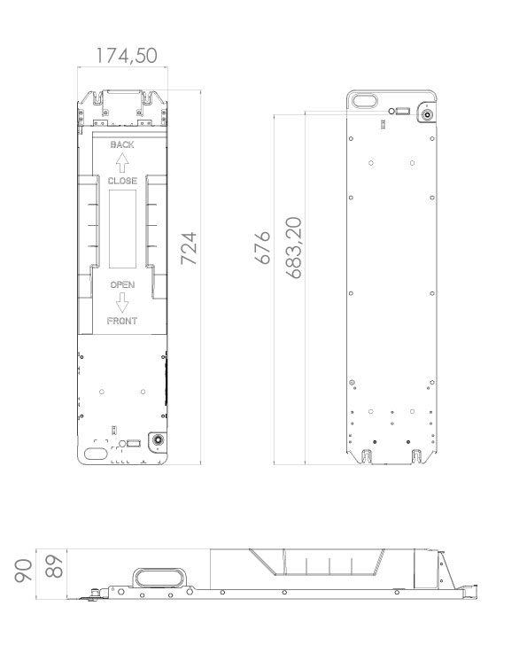
Figure 8 : Standard ORV2 Sled dimensions

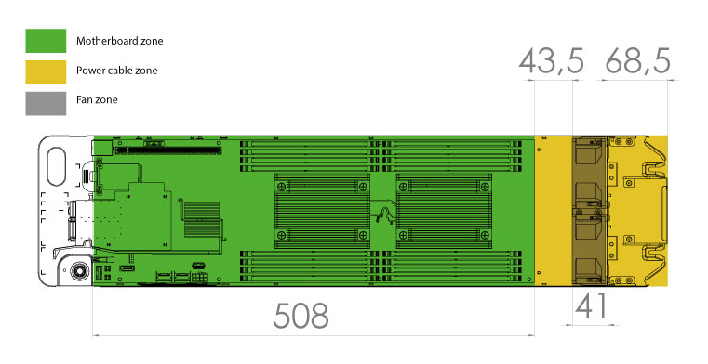
Figure 9 : Standard Sled ORV2 components zone

JBOG mechanical architecture

Architecture overview
JBOG integrates 4 GPU in 2 lines, with an air guide flushing the sides of the GPUs.
2 fans 80x80x38 mm are located at the back of the casing.
The air guide allows to force the passage of air through the GPU radiators, an opening is made on the side to allow a fresh air passage in the middle of the chassis between the two GPUs.
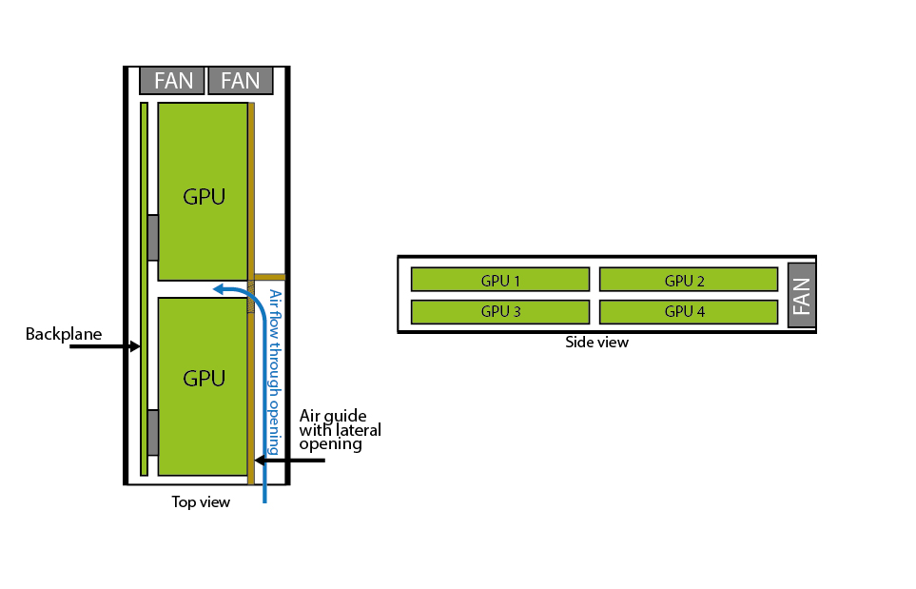
Figure 10 : Mechanical architecture

Mechanical dimensions
In accordance with the standard ORV2 dimensions, the sleds will measure L 724 x l 174.5 xH 90 mm
The backplane where the GPUs are connected must not exceed L 508 x l 80 mm

Thermal requirements
The mechanical design of the JBOG must comply with the requirements specified in the thermal specification document to allow efficient cooling.

Electrical requirement

Power distribution
Electrical power is supplied from the rack via the Cubby, which must be modified to provide sufficient power to the JBOG.
The medusa cables of the Cubby (ORV2) and Mini-Cubby (Sesame Fast Start) must be replaced by new ones capable of carrying enough power.
Connector part number table:
Part | Manufacturer | Reference
Sled Connector | TBD | TBD
Cubby Connector | TBD | TBD

Electrical grounding
Rack provides an electrically conductive path from the IT equipment in the rack to PSU ground.
This path shall not pass through any surfaces that are not protected from rust and corrosion such as un-plated surfaces.
All rack ground paths shall pass rust grade 6 per ASTM D610-01 after 48 hours of salt spray per ASTMB117-07.
Power board and other electrical component must be connected to the chassis ground.

Standards

Safety
TBD

EMC
TBD

Material requirement
TBD

